**Daily Scrum or Standup Meeting**

Team name: ______team 4___________________

Scrum Master: ____Brock Francom______________

Date:________11/13/19____________________

|  |  |  |  |
| --- | --- | --- | --- |
| **Team Member** | **What did you do since the last scrum?** | **What do you plan to do before the next scrum?** | **What obstacles do you have?** |
| Carter Figgins | Researched about unit testing | Getting unit testing done | Leaning how to unit test |
| Brock Francom | I got some more of the Admin pages working. | Unit test | I don’t know how to unit test. |
| Waseca Hodson | N/A | N/A | N/A |
| Sterling Tolley | Redesigned 80% of the website using bootstrap | Finish Redesign, add Full name and email fields to user table | NA |
|  |  |  |  |

# Burndown

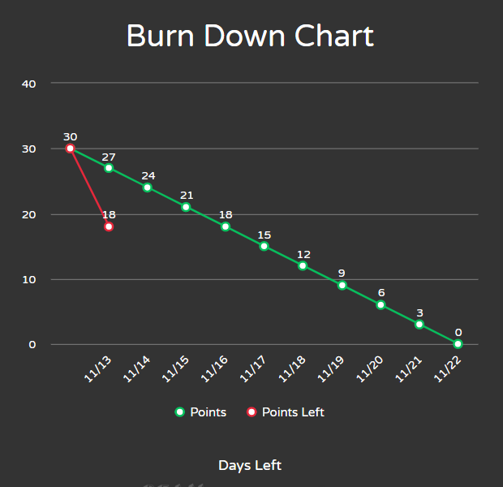

# Screenshot of you project board

